CREATE TABLE creative_team(

creative_id INT,

producer VARCHAR(255),

director VARCHAR(255),

scenarist VARCHAR(255),

operator VARCHAR(255),

editor VARCHAR(255),

composer VARCHAR(255),

actor VARCHAR(255),

PRIMARY KEY (creative_id)

);

CREATE TABLE investor(

company_id INT,

company VARCHAR(255),

PRIMARY KEY (company_id)

);

CREATE TABLE running_time(

time_id INT,

running_time TIME,

PRIMARY KEY (time_id)

);

CREATE TABLE release(

release_id INT,

release DATE,

PRIMARY KEY (release_id)

);

CREATE TABLE finance(

finance_id INT,

budget INT,

PRIMARY KEY (finance_id)

);

CREATE TABLE age_limit(

age_id INT,

age INT,

PRIMARY KEY (age_id)

);

CREATE TABLE rating(

rating_id INT,

rating INT,

PRIMARY KEY (rating_id)

);

CREATE TABLE movie(

id INT NOT NULL,

name VARCHAR(255),

country VARCHAR(255),

genre VARCHAR(255),

PRIMARY KEY (id),

team_id INT REFERENCES creative_team(creative_id),

time_id INT REFERENCES running_time(time_id),

release_id INT REFERENCES release(release_id),

finance_id INT REFERENCES finance(finance_id),

age_id INT REFERENCES age_limit(age_id),

rating_id INT REFERENCES rating(rating_id)

);

ALTER TABLE finance ADD COLUMN box_office INT;

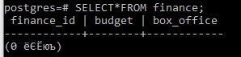

ALTER TABLE creative_team ALTER producer SET NOT NULL;

ALTER TABLE creative_team DROP COLUMN scenarist;

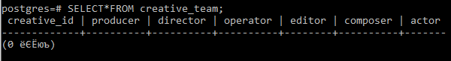

ALTER TABLE movie ADD COLUMN company_id INT;

ALTER TABLE movie ADD FOREIGN KEY (company_id) REFERENCES investor (company_id);



INSERT INTO creative_team

VALUES (1, ‘Darlene Mckenz’ ,'Poppy Quintero', 'Shamass Booth', 'Aleesha Crvantes','Sabina Cannon', 'Tim Robbins'),

(2, 'Lexie Vaugman', 'Lexie Vaugman', ‘Andrew Lesnie’, 'Dan Basset', 'Borris Peters', 'Mira Wills'),

(3, 'Jibril Crouch', 'Christopher Hukman', 'Havin Halliday', 'Naomi Sargent', 'Zayne House', 'Kalem Dunn'),

(4, 'Brandon Cooper', 'Mae Parry', 'Zara Gibbs', 'Bentley Schroeder', 'Zahra Millington', 'Elowen Potter'),

(5, 'Kia Villanueva', 'Tasha Lane', 'Arthur Tomlinson', 'Eathan Lin', 'Marek Spencer', 'Tom Holland'),

(6, 'Jayden Howard', 'Faheem Myers', 'Michele Wilkins', 'Ritchie Sutton', 'Samantha Gomez', 'Abu Flower'),

(7, 'Vivian Pineda', 'Caiden Drapper', 'Kavan Medrado','Victor','Sabiha Ridgy','Greg Gates');

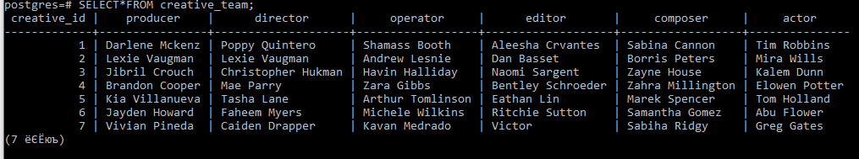

INSERT INTO investor

VALUES

(1, 'CastleView Productions'),

(2, 'Panoptica Films'),

(3, 'Premier Pictures'),

(4, 'Fox'),

(5, ‘EachFilm’),

(6, 'Cun Run'),

(7, 'Whisper Films');

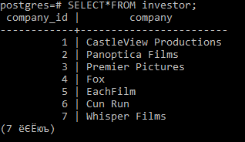

INSERT INTO running_time

VALUES

(1, '5:50'),

(2, '7:24'),

(3, '8:35'),

(4, '9:15'),

(5, '8:12'),

(6, '5:03'),

(7, '6:59');

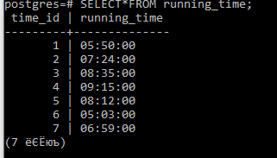

INSERT INTO release  
VALUES  
(1,'1992-10-11'),  
(2,'2002-04-15'),  
(3,'2011-12-30'),  
(4,'2019-03-13'),  
(5,'2005-06-16'),  
(6,'2000-11-23'),  
(7,'2014-11-09');

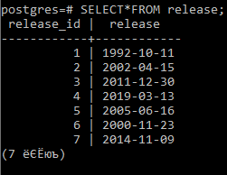

INSERT INTO age_limit

VALUES

(1, 16),

(2, 12),

(3, 18),

(4, 0),

(5, 6);

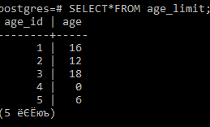

INSERT INTO FINANCE

VALUES

(1,1000000,2267382),

(2,850000,1892972),

(3,1781799,2936362),

(4,2789830,1029000),

(5,1000000,17827818),

(6,26737281,42658220),

(7,1000000,6362261);

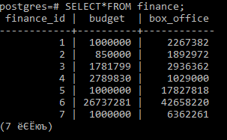

INSERT INTO rating

VALUES (1, 8),

(2, 8),

(3, 8),

(4, 7),

(5, 8),

(6, 3),

(7, 10);

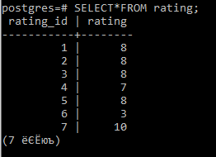

(id, name, country, genre, team_id, time_d, release_id, finance_id, age_id, rating_id, company_id)

INSERT INTO movie

VALUES (1, ‘Forrest Gump’, 'The USA', 'Drama', '1', '1', '1', '1', '2', '1', '1'),

(2, 'The Avengers', 'The USA', 'Fantasy', '2', '2', '2', '2', '1', '2', '2'),

(3, 'Fantasy', 'The USA', 'Fantasy', '3', '3', '3', '3', '2', '3', '3'),

(4, 'Spy', 'The USA', 'Comedy', '4', '4', '4', '4', '3', '4', '4'),

(5, 'The Joker', 'The USA', 'Criminal', '5', '5', '5', '5', '3', '5', '5'),

(6, '1+1', 'France', 'Drama', '6',' 6', '6', '6', '1', '6', '6'),

(7, 'Toy Story', 'The USA', 'Cartoon', '7', '7', '7', '7', '4', '7', '7')

;

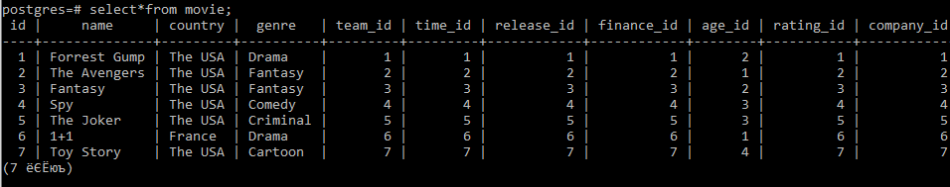

UPDATE creative_team SET director = 'Alfah Alnagi' WHERE director = 'Poppy Quintero';

UPDATE creative_team SET operator = null WHERE creative_id = 6;

UPDATE creative_team SET actor = null WHERE creative_id = 7;

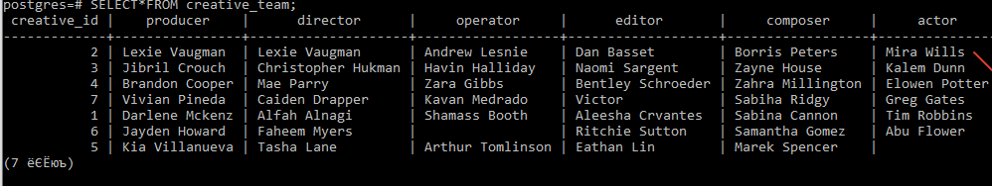

UPDATE investor SET company = 'ClearFilms' WHERE company_id = 3;

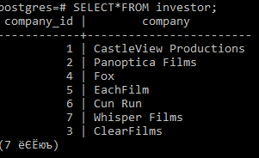

UPDATE running_time SET running_time = '7:47:00' WHERE time_id = 1;

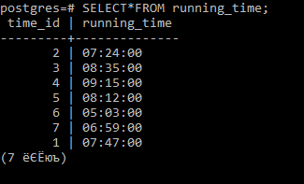

UPDATE release SET release = '2017-01-11' WHERE release_id = 4;

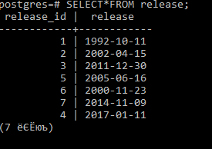

UPDATE finance SET box_office = 400000000 WHERE finance_id = 6;

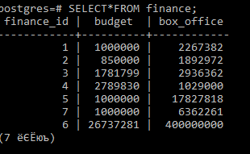

DELETE FROM movie WHERE country != 'France';

UPDATE movie SET genre = 'Comedy' WHERE genre = 'Drama';

